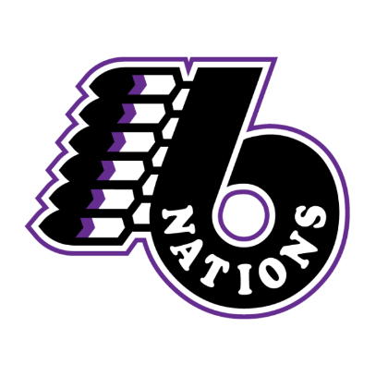
SIX NATIONS MINOR LACROSSE ASSOCIATION
2024 COACHING APPLICATION

Contact Information

NAME:
EMAIL:
CELL:

1. What division are you applying for? |  |  | Please Circle
1st Choice – Division |  | Team #: | 1 | 2 | 3
2nd Choice – Division |  | Team #: | 1 | 2 | 3

2. What team role are you applying for? |  | 3. What is your NCCP #
- Head Coach
- Assistant Coach
- Trainer

4. Do you have a child playing on the team you are applying for? Yes ☐
No ☐

5. Are you willing to complete a Police Check? Yes ☐
No ☐

6. What is your coaching experience/history?

7. Briefly describe your season plan? What do you want to accomplish for the 2024 season?

8. Please list bench staff name and NCCP #.

Assistant Coach:
Assistant Coach:
Trainer:

SNMLA will be conducting interviews with all candidates, you will be contacted for your interview date and time.

Please Submit Application by November 30, 2023 in person to any SNMLA Team Member or Email: snminorlacrosse@gmail.com

